Author Guidelines for IWAENC 2022 Proceedings Manuscripts
Author(s) Name(s)
Author Affiliation(s)

Abstract
The abstract should appear at the top of the left-hand column of text, about 0.5 inch (12 mm) below the title area and no more than 3.125 inches (80 mm) in length. Leave a 0.5 inch (12 mm) space between the end of the abstract and the beginning of the main text. The abstract should contain about 100 to 150 words, and should be identical to the abstract text submitted electronically. All manuscripts must be in English.
Index Terms— One, two, three, four, five

1. Introduction
These guidelines include complete descriptions of the fonts, spacing, and related information for producing your proceedings manuscripts. If you have any questions regarding the paper submission, please contact the conference organizers via email submission@iwaenc2022.org.

2. Formatting your paper
The properly formatted paper should be not longer than 4 pages in A4 format (210 mm x 297 mm). All printed material, including text, illustrations, and charts, must be kept within a print area of 7 inches (178 mm) wide by 9 inches (229 mm) high. Do not write or print anything outside the print area. The top margin must be 1 inch (25 mm), except for the title page, and the left margin must be 0.63 inch (16 mm). All text must be in a two-column format. Columns are to be 3.39 inches (86 mm) wide, with a 0.24 inch (6 mm) space between them. Text must be fully justified.

3. Page title section
The paper title (on the first page) should begin 1.38 inches (35 mm) from the top edge of the page, centered, completely capitalized, and in Times 12-point, boldface type. The authors’ name(s) and affiliation(s) appear below the title in capital and lower case letters. Papers with multiple authors and affiliations may require two or more lines for this information. Please note that papers must include the authors’ name(s) and affiliation(s) on the PDF.

4. Type-style and fonts
To achieve the best rendering, we strongly encourage you to use Times-Roman font. In addition, this will give the online proceedings a more uniform look. Use a font that is no smaller than 9-point type throughout the paper, including figure captions.
In 9-point type font, capital letters are 2 mm high. If you use the smallest point size, there should be no more than 3.2 lines/cm (8 lines/inch) vertically. This is a minimum spacing; 2.75 lines/cm (7 lines/inch) will make the paper much more readable. Larger type sizes require correspondingly larger vertical spacing. Please do not double-space your paper. TrueType or Postscript Type 1 fonts are preferred.
The first paragraph in each section should not be indented, but all following paragraphs within the section should be indented as these paragraphs demonstrate.

5. MAjor headings
Major headings, for example, “1. Introduction”, should appear in all capital letters, bold face if possible, centered in the column, with one blank line before, and one blank line after. Use a period (“.”) after the heading number, not a colon.

5.1. Subheadings
Subheadings should appear in lower case (initial word capitalized) in boldface. They should start at the left margin on a separate line.

5.1.1. Sub-subheadings
Sub-subheadings, as in this paragraph, are discouraged. However, if you must use them, they should appear in lower case (initial word capitalized) and start at the left margin on a separate line, with paragraph text beginning on the following line. They should be in italics.

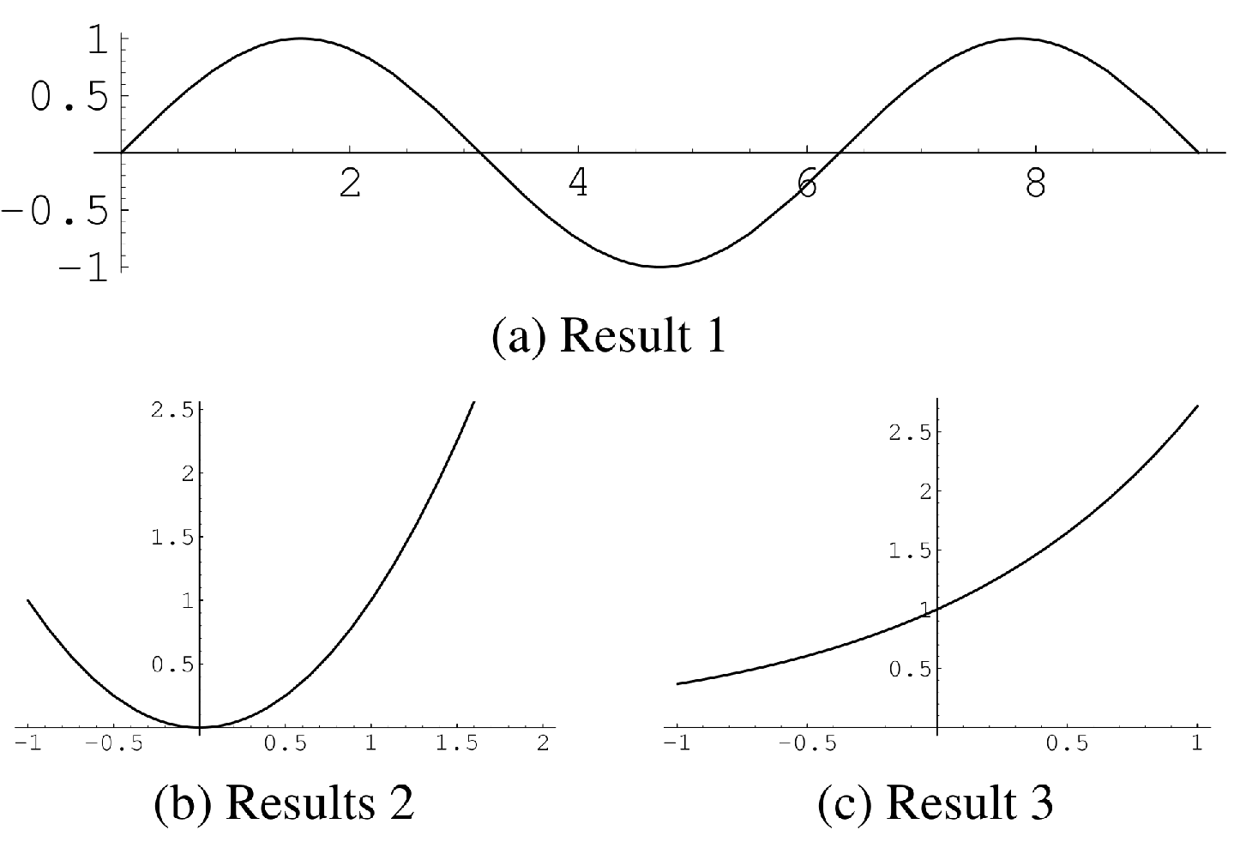
Fig. 1. Example of placing a figure with results.

6. Page numbering
Please do not paginate your paper. Page numbers and conference identification will be inserted when the paper is included in the proceedings.

7. Illustrations, graphs, and photographs
Illustrations must appear within the designated margins. They may span the two columns. If possible, position illustrations at the top of columns, rather than in the middle or at the bottom. Caption and number every illustration. All halftone illustrations must be clear black-and-white prints. Colors may be used, but they should be selected so as to be readable when printed on a black-only printer.
There are many (often incompatible) ways of including images (e.g., with experimental results) in a Word document, and an example of how to do this is provided by Fig 1.

8. Footnotes
Use footnotes sparingly (or not at all!) and place them at the bottom of the column on the page on which they are referenced. Use Times 9-point type, single-spaced. To help your readers, avoid using footnotes altogether and include necessary peripheral observations in the text (within parentheses, if you prefer, as in this sentence).

9. RElation to prior work
The text of the paper should contain discussions on how the paper's contributions are related to prior work in the field. It is important to put new work in context, to give credit to foundational work, and to provide details associated with the previous work that have appeared in the literature. This discussion may be a separate, numbered section or it may appear elsewhere in the body of the manuscript, but it must be present. You should differentiate what is new and how your work expands on or takes a different path from prior studies.

10. References
List and number all bibliographical references at the end of the paper. The references can be numbered in alphabetical order or in order of appearance in the document. When referring to them in the text, type the corresponding reference number in square brackets as shown at the end of this sentence [1, 2]. An additional final page (the fifth page, in most cases) is allowed, but must contain only references to the prior literature.

11. References
- A. B. Smith, C. D. Jones, and E. F. Roberts, “Article Title,” Journal, vol. 62, pp. 291–294, Jan. 1920.
- C. D. Jones, A. B. Smith, and E. F. Roberts, “Article Title,” in Proceedings Title. IEEE, 2003, vol. II, pp. 803–806.

